Supplemental Nutrition Assistance Program (SNAP) Meal Gaps 2020

The "SNAP Meal Gap - 2020 Data" dataset provides insights into the Supplemental Nutrition Assistance Program (SNAP) and related meal gaps for 2020. It highlights key attributes such as geographic location, meal gaps, income levels, and SNAP participation rates, enabling analyses of food security and the distribution of SNAP benefits. This data helps identify regions with significant meal gaps and areas needing intervention. To enhance this analysis, two additional datasets were integrated: a Racial Demographics Dataset, offering regional racial composition, and a Financial Health Indicators Dataset, covering metrics like median income, unemployment rates, and poverty levels. These datasets enable a comprehensive evaluation of societal disparities and inform policy-level solutions.

Extract: Data was retrieved from a MongoDB collection named "snap_meal_gap," converted into a pandas DataFrame, and stored in a dictionary for processing. The ‘_id’ column was removed to simplify the dataset. The modified DataFrame was displayed to ensure the data extraction process was successful and ready for transformation.
Transform: Data Inspection and Cleaning: The dataset was summarized to show column names, non-null counts, and data types. Missing values were identified using isnull().sum() to pinpoint potential data quality issues. This step provided a clear understanding of the data's structure and readiness for analysis.
Standardizing Columns: Column names were converted to lowercase, and spaces were replaced with underscores, ensuring a consistent and readable format. These changes facilitated easier querying and manipulation.
Removing Redundancy: The county_fips column was removed since county_state uniquely identified regions, eliminating unnecessary duplication. Duplicate rows were also dropped to ensure data integrity.
Consistent Formatting: The state column was formatted to uppercase and county_state to title case for uniformity. These changes supported consistency when analyzing regional data.
Normalization: The cost_per_meal column was normalized using Min-Max Scaling, transforming its values to a range between 0 and 1. This created a new column, normalized_cost_per_meal, allowing consistent comparisons across regions.
Derived Metrics: Two additional columns were calculated:
cost_per_capita: Adjusted cost per meal multiplied by total population, reflecting the population-adjusted cost.
total_gap_cost: Aggregated gap cost calculated by multiplying gap_cost_snap by total population, offering insights into the financial burden of meal gaps.
Region Mapping: A region column was added by mapping state abbreviations to regions (e.g., South, West) using a predefined dictionary. This enabled regional comparisons in the analysis.
Outlier Removal: Outliers in specified columns were removed using the Interquartile Range (IQR) method. This ensured the dataset retained only values within 1.5 times the IQR from the first (Q1) and third quartiles (Q3), improving data reliability.
Load: The transformed dataset was uploaded to a PostgreSQL database using SQLAlchemy. The DataFrame was written to a table named SNAP_meal_gap, replacing any existing table with the same name. After writing, the database connection was safely closed, ensuring secure and efficient data handling.

Tools and Technologies:
Python: It is chosen for its simplicity. Also, it is ideal for data analysis, machine learning, and automation tasks. Its libraries and active community make it well-suited for rapid development.
Jupyter Notebook: Provided an interactive environment for writing and executing code, allowing seamless integration of explanations, code, and visual outputs. This improved reproducibility and enhanced collaboration.
Pandas: Enabled efficient data manipulation through its powerful DataFrame structure. It facilitated operations such as cleaning, merging datasets, calculating metrics, and visualizing data.
NumPy: Supported fast numerical computations, forming the foundation for many operations in Pandas and other data science libraries. Its efficiency with multi-dimensional arrays made it essential for scientific computing.
Matplotlib and Seaborn: These libraries provided tools for data visualization. Matplotlib offered customization options for detailed graphs, while Seaborn simplified statistical visualizations, creating aesthetically appealing and informative plots.
scikit-learn: Used for machine learning tasks, it provided robust tools for regression, classification, clustering, and scaling. Its APIs simplified complex algorithms, ensuring smooth integration into the workflow.
PostgreSQL and MongoDB: PostgreSQL, a reliable relational database, handled structured data with advanced querying capabilities. It ensured data consistency and integrity. MongoDB, a NoSQL database, was ideal for storing semi-structured or unstructured data, offering scalability and flexibility.
SQLAlchemy: This Python library streamlined database interactions, allowing for efficient writing of transformed data into PostgreSQL tables. Its ORM capabilities simplified complex database queries and operations.

Key Insights:
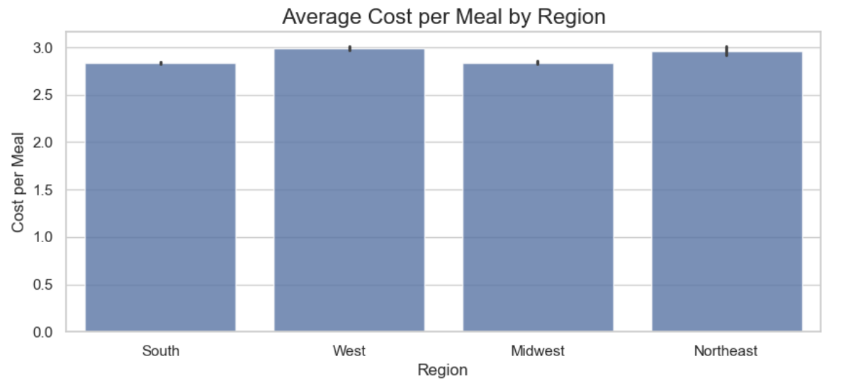
Cost Per Meal by Region: The West and Northeast regions have the highest average cost per meal. Costs are relatively uniform across regions, with minor variations.

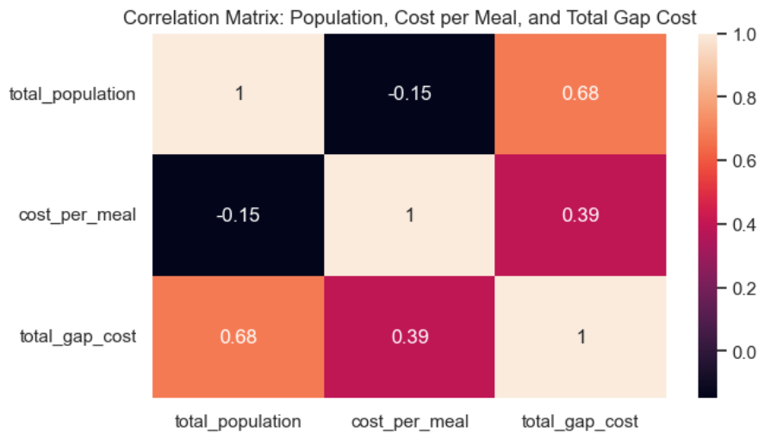
Correlation Matrix: A strong positive correlation (0.68) exists between total population and total gap cost, indicating higher populations lead to greater gap costs. A moderate positive correlation (0.39) between cost per meal and total gap cost suggests cost contributes but is not the primary driver. Cost per meal negatively correlates (-0.15) with total population, implying larger populations tend to have slightly lower meal costs.

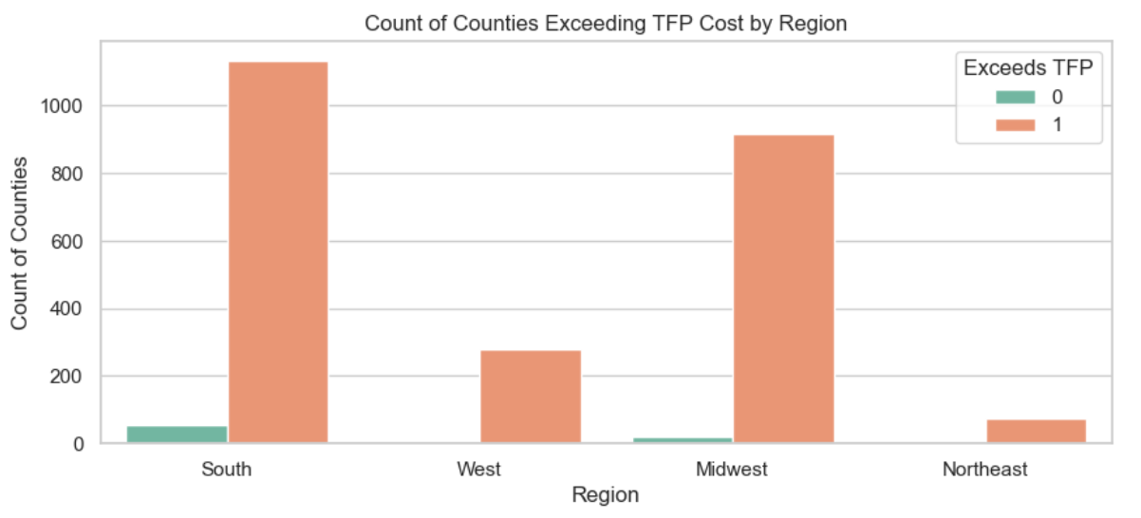
Counties Exceeding TFP Cost: The South and Midwest regions have the highest counts of counties exceeding the Thrifty Food Plan (TFP) cost, with the South leading significantly. The West and Northeast show fewer such counties, reflecting regional disparities.

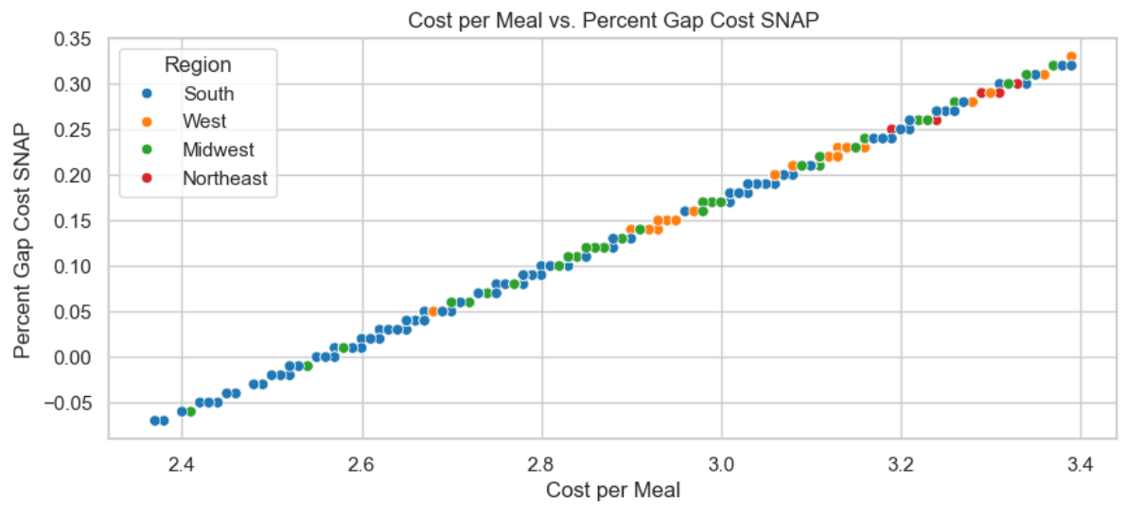
Cost Per Meal vs. Percent Gap Cost SNAP: A scatter plot shows a positive linear relationship between these variables across all regions. As meal costs rise, so does the percent gap cost, revealing a consistent trend regardless of geography.

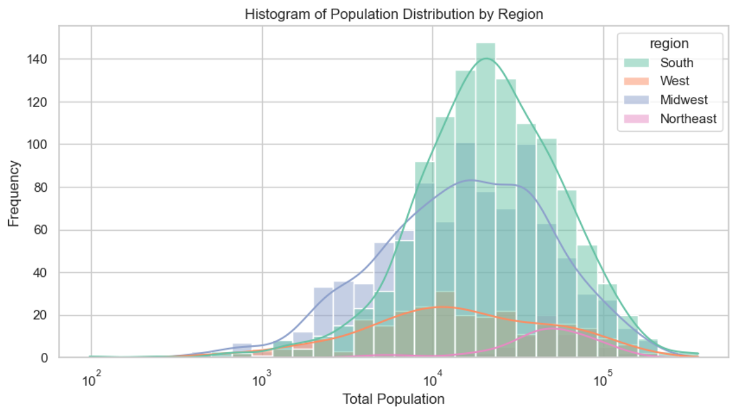
Population Distribution by Region: The South dominates with the highest population frequencies, particularly in mid-to-higher ranges. The Midwest shows moderate frequencies with a concentration in smaller population ranges. In contrast, the West and Northeast have smaller, skewed populations, highlighting disparities in population distribution.

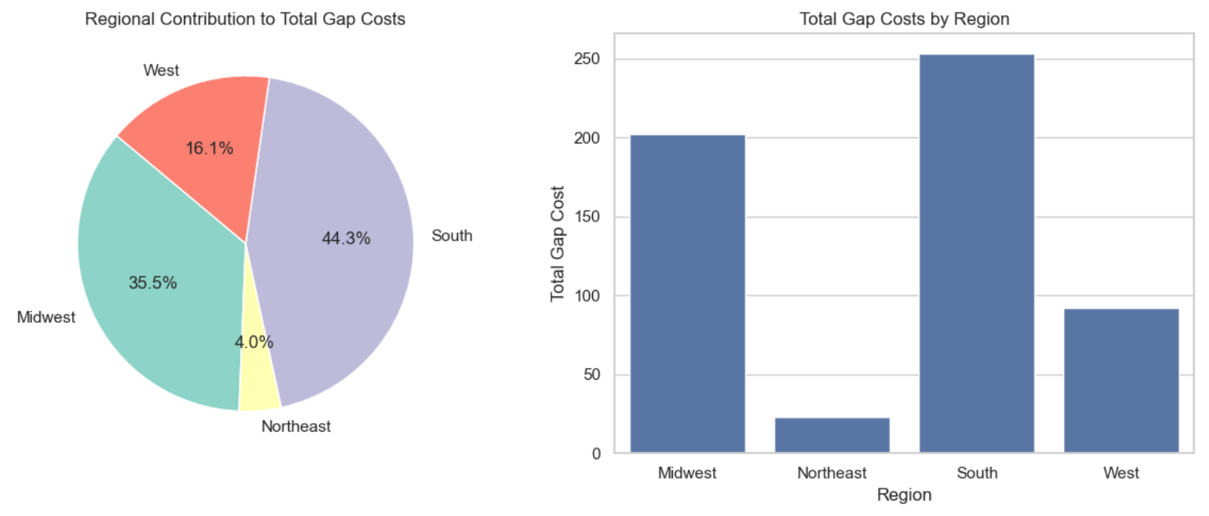
Regional Contributions to Total Gap Costs: The South accounts for 44.3% of the total gap costs, followed by the Midwest at 35.5%. The West contributes 16.1%, while the Northeast has the smallest share (4%). This underscores significant disparities, with the South and Midwest bearing the largest burdens.

